Ansible lab set
- Create two instances with amazon linux (give names ansible-server and host-server)
- Connect two instances
Name ansible server as ansible-server
- sudo hostnamectl set-hostname ansible-server
- bash
Execute following commands only on ansible server
sudo yum update -y
sudo dnf update -y

sudo dnf install -y ansible

sudo curl -o /etc/ansible/ansible.cfg https://raw.githubusercontent.com/ansible/ansible/stable-2.15/examples/ansible.cfg

ansible --version

- After running the above command, you will get 404 error and to resolve the error follow the screenshot and execute marked second command
cd /etc/ansible
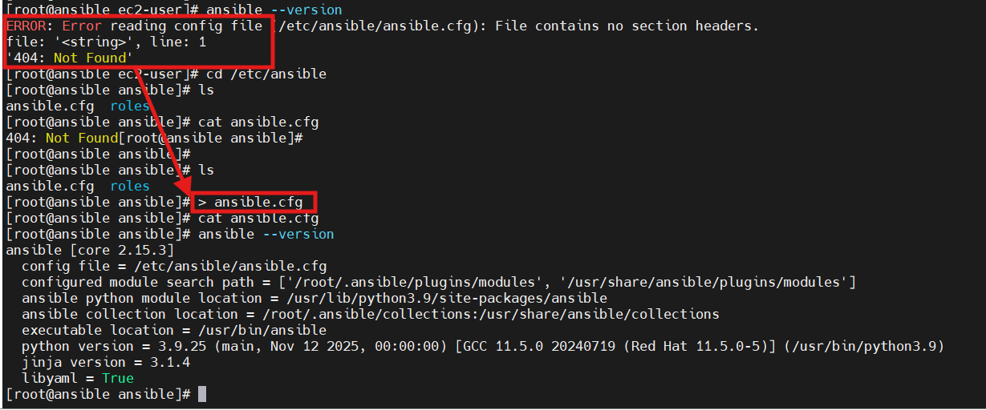

cd /etc/ansible

# open ansible ansible.cfg and add below lines inside the file

[defaults]
inventory = /etc/ansible/hosts
host_key_checking = False
retry_files_enabled = False
sudo_user = root

vi ansible.cfg
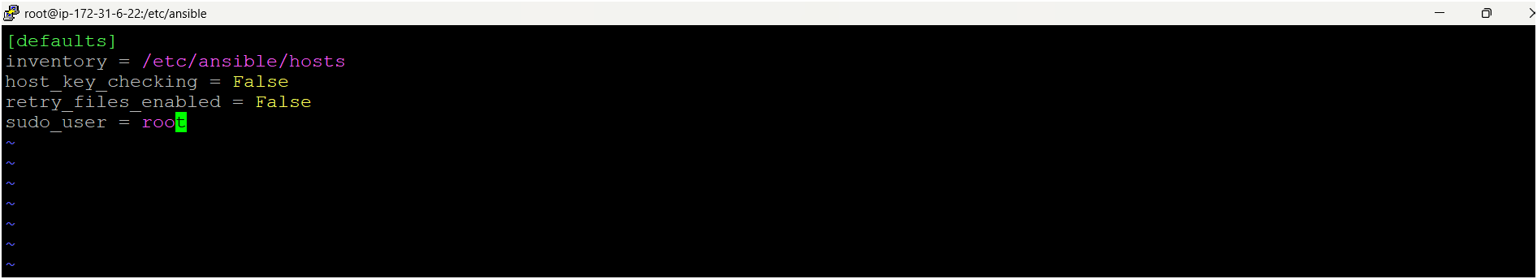
ESC + :wq

# Create a file named hosts after open hosts file and add webservers and add your target machine pvt ip add
vi hosts
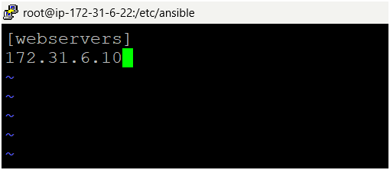

- Come to home directory
cd /home/ec2-user
- Create one user for ansible
useradd ansible
- Set a password for this user
passwd ansible
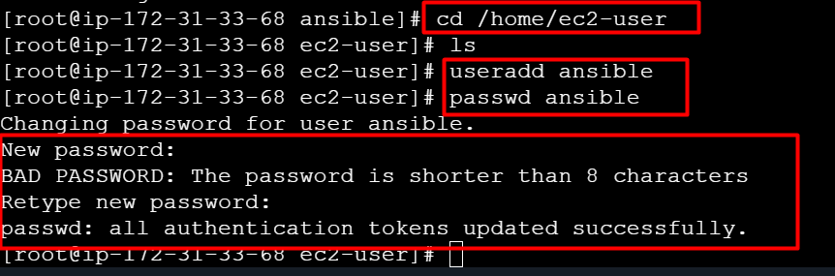

- Become as a ansible user
su - ansible
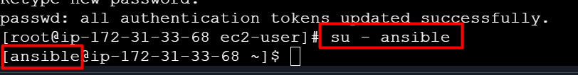

- Next you need to provide sudo privileges to ansible user (exit from the ansible user)
- Open visudo file
visudo
add this command under Root line ansible ALL=(ALL) NOPASSWD: ALL
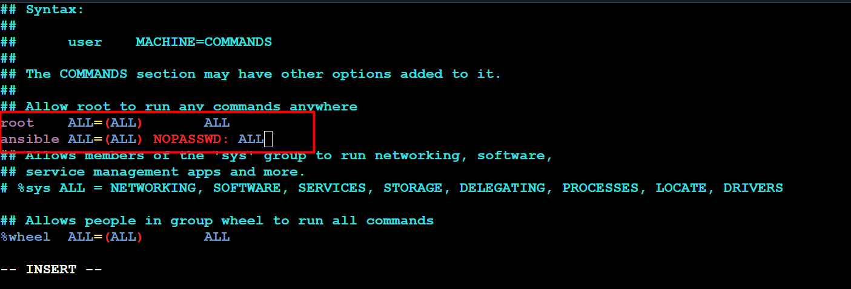
Ctrl X => Ctrl Y => Enter
- Now create one ansible user on host-server/target machine as same as ansible-server and give same password here.
- Open visudo file and give sudo privileges to ansible user
visudo
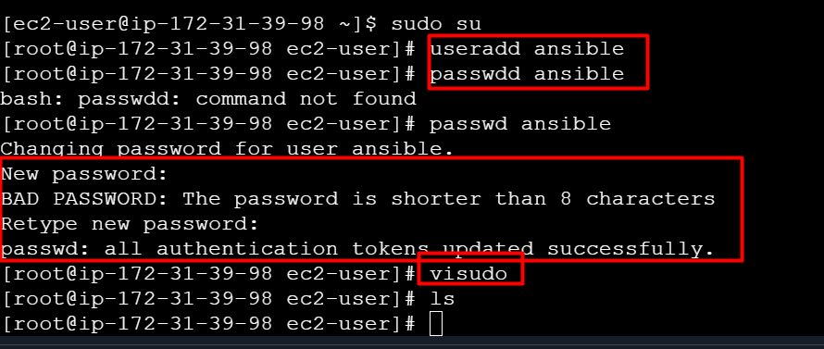
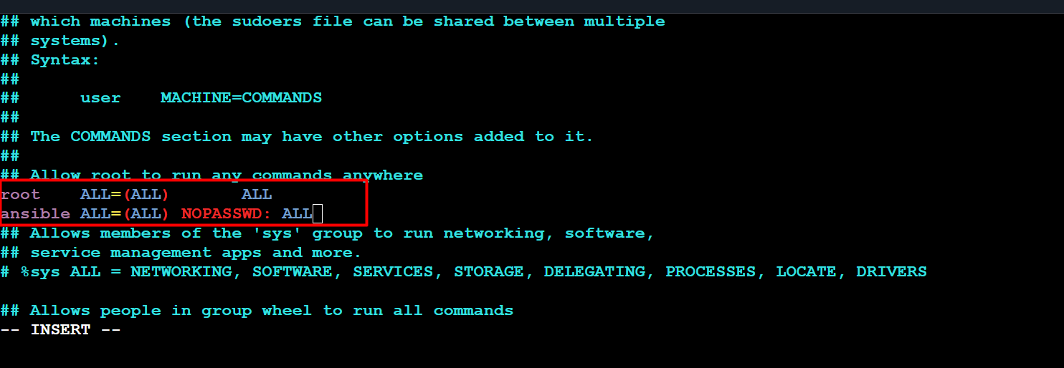
Ctrl X => Ctrl Y => Enter
- We have to establish connection between ansible server and host server, follow the below steps on ansible server
- Open file /etc/ssh/sshd_config
vi /etc/ssh/sshd_config
- Uncomment for PermitRootLogin prohibit-passwd but remove prohibit-password replace with yes and find out this line passwordAuthentication no but remove no replace with yes
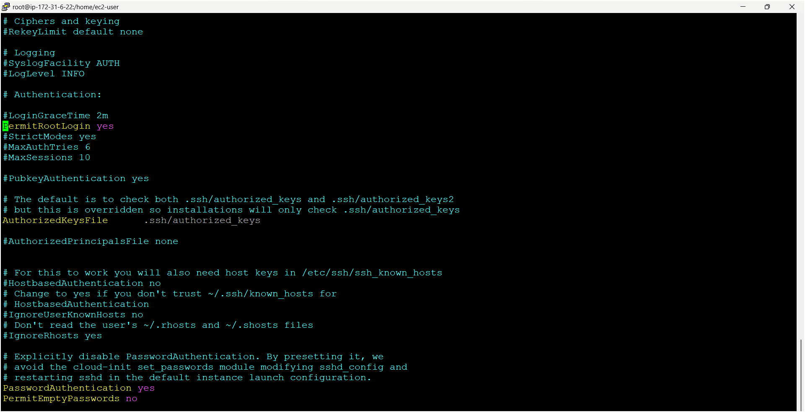



- Same steps do for host-server also ️
- vi /etc/ssh/sshd_config
- Uncomment for PermitRootLogin prohibit-passwd but remove prohibit-password replace with yes and find out this line passwordAuthentication no but remove no replace with yes


- Now you need to check connection between ansible-server and host-servers
- Next you need to restart servers both ansible-server and host-server
service sshd restart (on both servers)
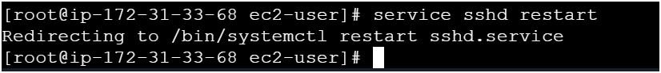
- Now become as a ansible user on ansible-server
- Next Copy pvt ip address of host-servers
- Go to ansible server use below command
ssh <pvt-ip-add> (#host-server pvt ip add)
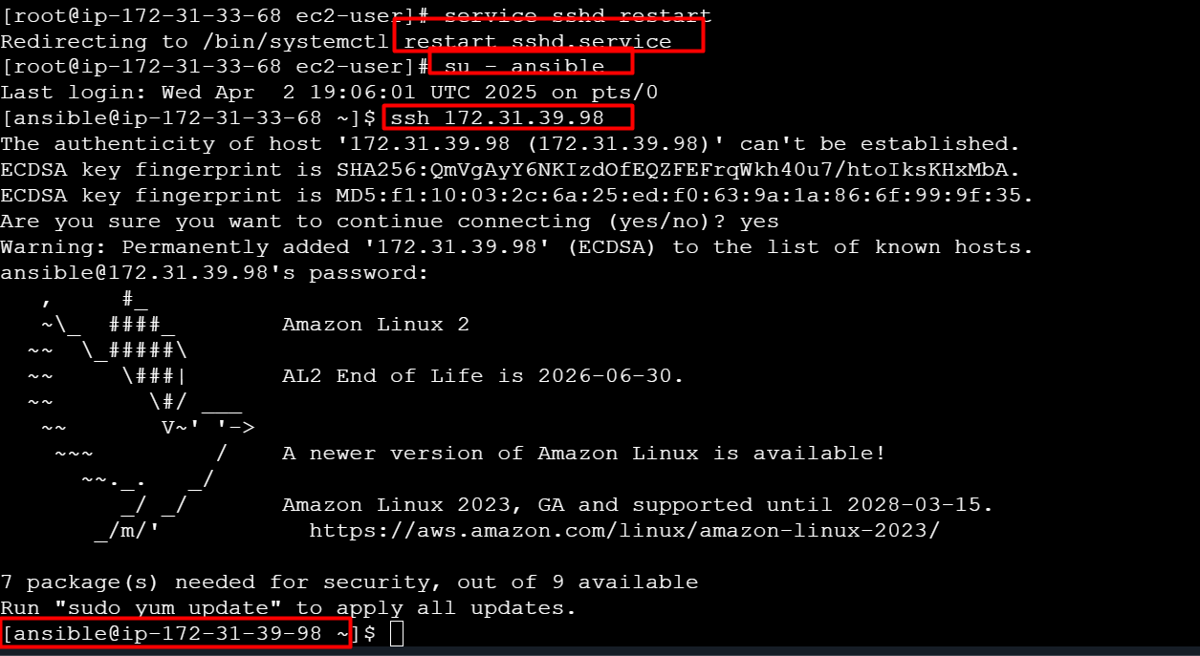
- Now its connected to your host-server (check pvt ip add of host-server)️
- Next exit from the host-server

- Now you need to make connection between servers without providing password and follow below commands on ansible-server 👇 (run commands as an ansible user only)
ssh-keygen (it will generate two types keys one is public key & pvt key)
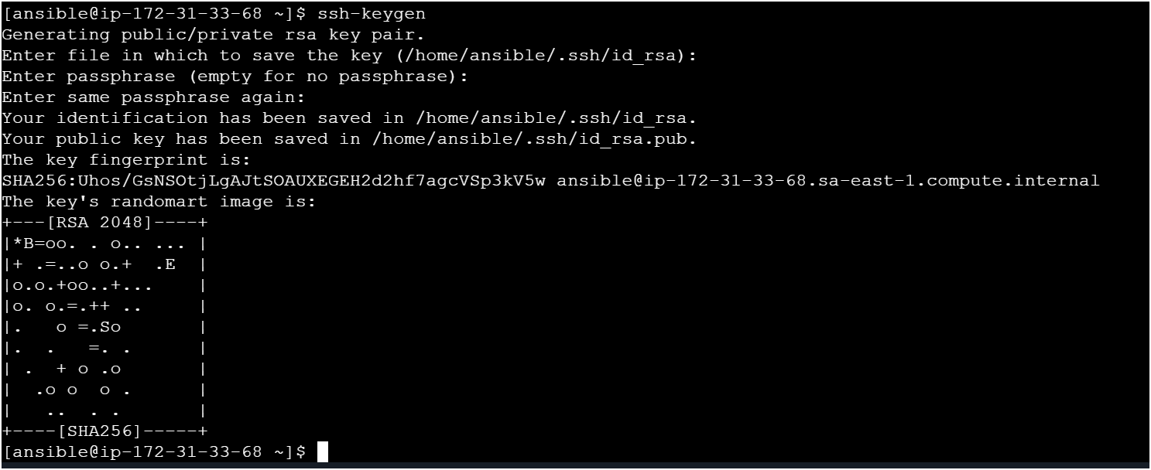
- Now look for key using
ls -la
cd ..ssh
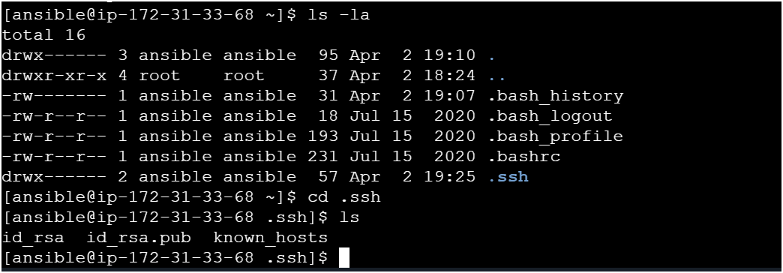
- How to copy public key to host-server from ansible-server
ssh-copy-id ansible@pvt-ip-add-of-host-server and it will ask passwd provide ansible user passwd only
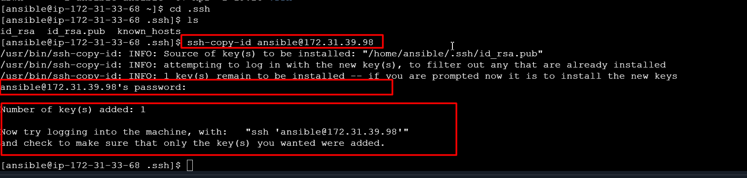

- Now do cross check by login to host-server from ansible-server without providing any passwd using below command
ssh <pvt-ip-add> (host-server-pvt-ip-add)
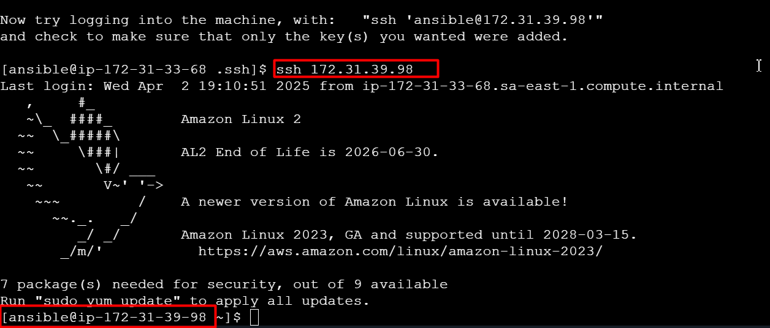
- Now you can check on host-server whether key is copied or not
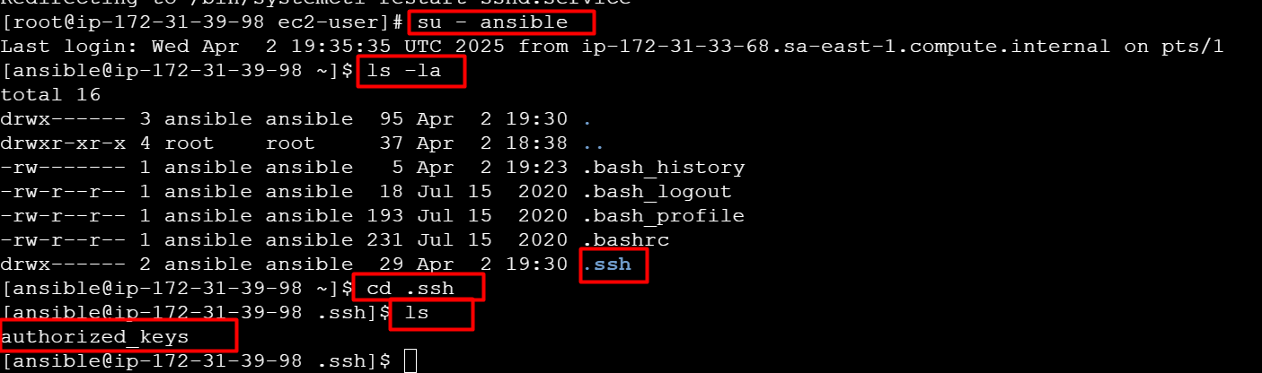

- Also you can check the connection from ansible-server using below command
ansible webservers -a “ls”
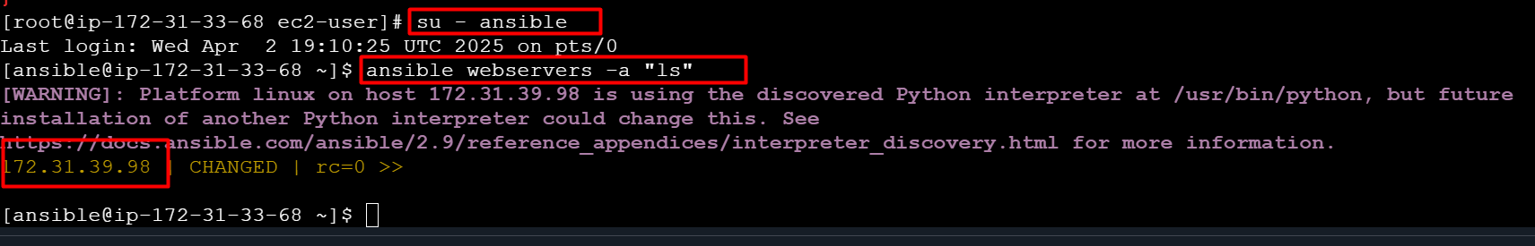
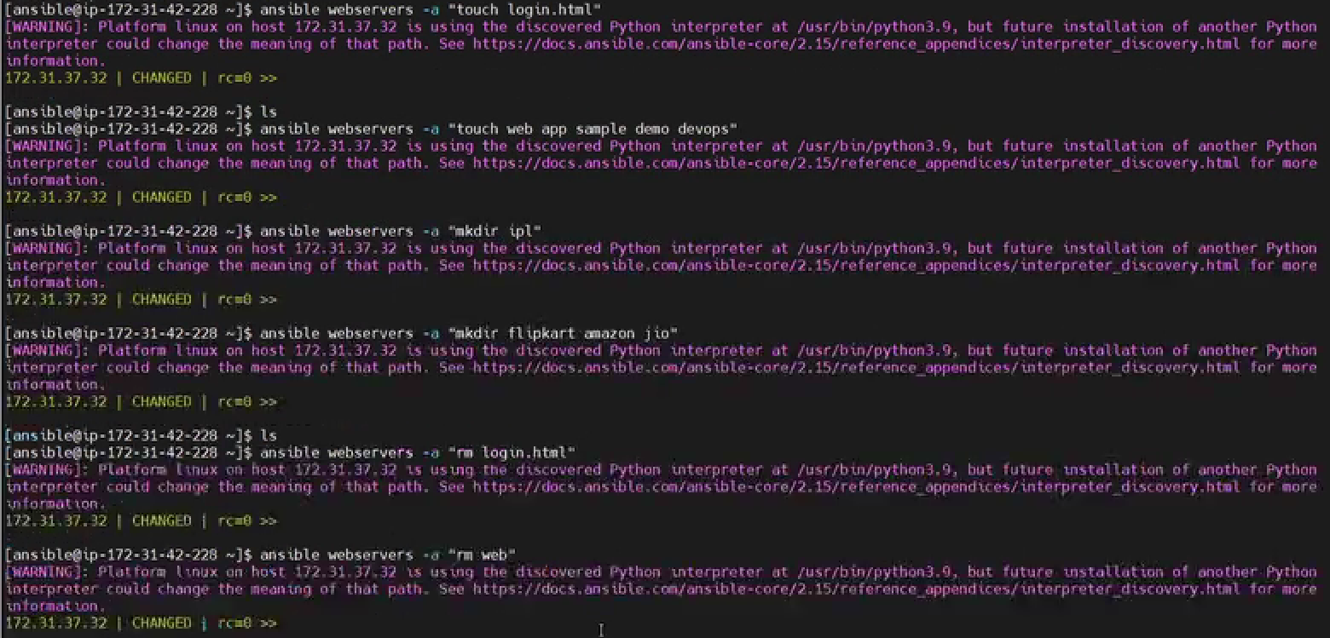
Removing multiple files
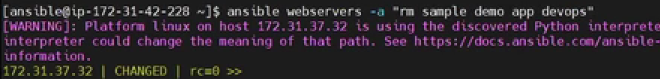
Lab set was done
========================================================
Go to Ansible Server
- Now we have to write playbooks use following script
- Write playbooks on ansible-server only
- Create a file named with “my-demo-playbook.yaml”
vi my-demo-playbook.yaml
---
- hosts: webservers
user: ansible
become: yes
connection: ssh
tasks:

- name: install java on host machine
action: yum pkg=java state=present

- name: install mysql on host machine
action: yum pkg=mysql state=present

- name: install httpd on host machine
action: yum pkg=httpd state=present

- name: install docker on host machine
action: yum pkg=docker state=present

- name: install git on host machine
action: yum pkg=git state=present

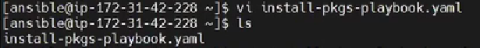
Copy yml file
Check Syntax
If there are errors it shows up error.
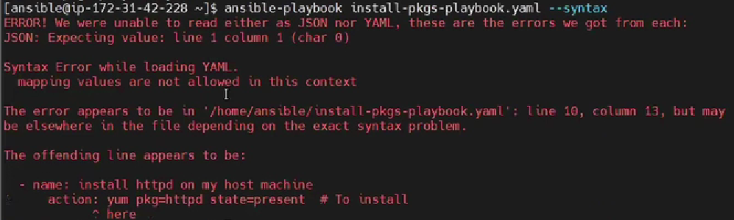
dry run before doing actual run 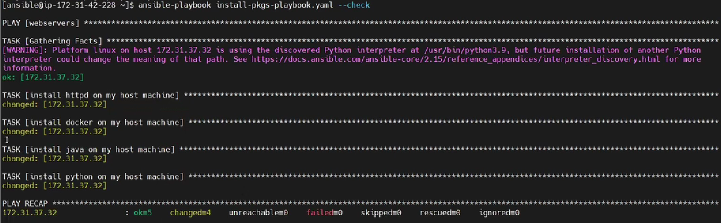
Now run the command to install the required as per yaml file.
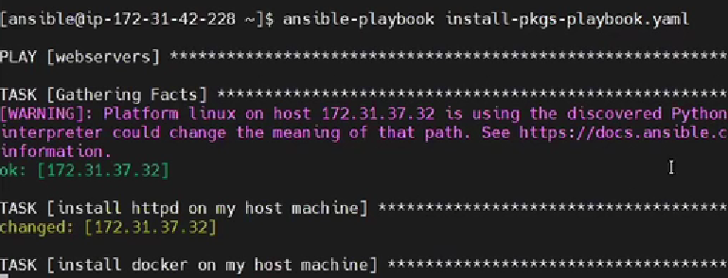
Check in Target Server.
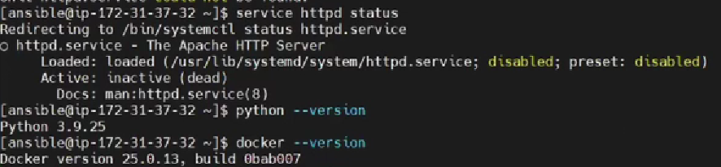
# after installation is completed we can start services
- name: start httpd on host machine
action: service name=httpd state=started

- name: stop httpd on host machine
action: service name=httpd state=stopped

- name: restart httpd on host machine
action: service name=httpd state=started

- name: start docker on host machine
action: service name=docker state=started

- name: stop docker on host machine
action: service name=docker state=stopped

- name: restart docker on host machine
action: service name=docker state=started

- Now check syntax errors in your playbook
ansible-playbook <file-name> --syntax
- Next do a dry run before doing actual run
ansible-playbook <file-name> --check
- Now you can run your playbook
ansible-playbook <file-name>
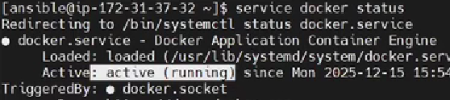
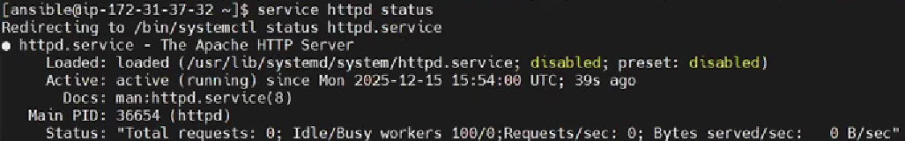
---
- name: Deploy IPL-SRH static site on Apache
hosts: webservers
become: yes
remote_user: ansible
connection: ssh

tasks:
- name: Install Apache (httpd)
ansible.builtin.yum:
name: httpd
state: present

- name: Start and enable Apache service
ansible.builtin.service:
name: httpd
state: started
enabled: yes

- name: Copy index.html
ansible.builtin.copy:
src: /home/ansible/IPL-SRH/index.html
dest: /var/www/html/index.html
owner: root
group: root
mode: 0644

- name: Copy CSS files
ansible.builtin.copy:
src: /home/ansible/IPL-SRH/ipl_src_css/
dest: /var/www/html/ipl_src_css/
owner: root
group: root
mode: 0755

- name: Copy images
ansible.builtin.copy:
src: /home/ansible/IPL-SRH/images/
dest: /var/www/html/images/
owner: root
group: root
mode: 0755

---
This is the standard YAML document start indicator. It tells YAML parsers this is the beginning of a new document.

- name: Deploy IPL-SRH static site on Apache
👉 This begins a play in Ansible.
- name: is just a human-readable label so you know what this play is doing.

hosts: webservers
👉 This tells Ansible which group of hosts to run the play on.
- In your inventory file (inventory.ini), you defined a group called webservers.

become: yes
👉 This means Ansible should become root (via sudo) when running tasks, because installing packages or managing services needs elevated permissions.

remote_user: ansible
👉 This is the SSH user Ansible will use to connect to the target machines.
In your case you created an ansible user on the target EC2 instance.

connection: ssh
👉 Tells Ansible to use SSH for connections (the default, but you can be explicit).

tasks:
👉 Starts a list of tasks to execute on the target hosts.

- name: Install Apache (httpd)
👉 Human-friendly description of the first task.

ansible.builtin.yum:
name: httpd
state: present
👉 This uses the yum module to:
install the httpd package (Apache web server)
state: present means “make sure it is installed”.

- name: Start and enable Apache service
👉 Next task description — manage Apache’s service.

ansible.builtin.service:
name: httpd
state: started
enabled: yes
👉 Uses the service module to:
ensure the httpd service is running (state: started)
and it is enabled at boot (enabled: yes)

- name: Copy index.html
👉 Next task: copy the HTML home page to the web server directory.

ansible.builtin.copy:
src: /home/ansible/IPL-SRH/index.html
dest: /var/www/html/index.html
owner: root
group: root
mode: 0644
👉 Uses the copy module to:
copy index.html from your control node (the Ansible machine)
to the target node’s web root
set owner/group to root
set file permissions to 0644 (readable by everyone, writable by root)

- name: Copy CSS files
👉 Copies CSS assets in a similar way.

ansible.builtin.copy:
src: /home/ansible/IPL-SRH/ipl_src_css/
dest: /var/www/html/ipl_src_css/
owner: root
group: root
mode: 0755
👉 Copies the entire CSS directory to the web server.
0755 means read/execute by everyone, write for owner only.
This is fine for static assets like CSS.

- name: Copy images
👉 Copies the images directory to the server.

ansible.builtin.copy:
src: /home/ansible/IPL-SRH/images/
dest: /var/www/html/images/
owner: root
group: root
mode: 0755
👉 Again, standard directory copy, with safe permissions.
=======================================
# install Jenkins on target machine

sudo yum update -y
sudo amazon-linux-extras install java-openjdk11 -y
wget -O /etc/yum.repos.d/jenkins.repo \
https://pkg.jenkins.io/redhat-stable/jenkins.repo
sudo rpm --import https://pkg.jenkins.io/redhat-stable/jenkins.io-2023.key
sudo yum install jenkins -y
sudo systemctl enable jenkins
sudo systemctl start Jenkins
=========================================================
# execute this commands on ansible server
ansible-galaxy collection install amazon.aws

=====================================
# Jenkins pipeline script

pipeline {
agent any

environment {
ANSIBLE_INVENTORY = "/var/lib/jenkins/inventory.ini"
}

stages {
stage('Checkout') {
steps {
git 'https://github.com/Msocial123/IPL-SRH.git'
}
}

stage('Run Ansible Playbook') {
steps {
sh """
ansible-playbook -i ${ANSIBLE_INVENTORY} ${WORKSPACE}/ipl-playbook.yml
"""
}
}
}

post {
success {
echo '✅ Deployment successful!'
}
failure {
echo '❌ Deployment failed.'
}
}
}

